User Requirements Specification

Group 2

Kalina Petrova (2221667)

Raditya Pratama (2221796)

Ishant Upadhyay (2309173)

Class Ei8s2

Mentor: Chung Kuah

Table of Contents

Introduction 3

Game Lore 3

Functional Requirements 3

MoSCoW Table 3

Use Cases: 4

Play battle 4

Choose Character 5

Choose Skill 6

Allocate Attribute Points 6

Chat with player within the game 7

Chat with players in lobby 7

Register 8

Login with existing account 8

Matchmaking 9

Use Case Diagrams: 10

User Interface 11

Login page 11

Choose Nation 12

Lobby 13

Game 14

Non-Functional Requirements 15

Rules and Constrains 15

# Introduction

We decided create a turn based text based fighting game. Users will be able to register an account on our server. Once they log in for the first time they would be asked to create a character-first by choosing their nation/alliance then the type of a warrior they’d wish to create. The users will be able to choose from one of 4 nations (water, fire, air, earth) and one of 3 classes (mage, warrior, archer).Once they have a character, the user can then play against other people that are logged in on the server-either by choosing his opponent or by being automatically matched up. People would also be able to chat during the waiting period with all the online players or to chat in game with their opponent.

Each character will have certain attributes like attack, defense, magical attack and so on. Each battle nets the players experience points. Once the character reaches certain experience points he levels up and is given a set amount of attribute points which the user can allocate. The modifiers for these attributes would be determined depending on the classes and elements of the character and the character he’s pitted against.

# Game Lore

# Functional Requirements

## MoSCoW Table

|  |  |
| --- | --- |
| Use-cases: | Implementation: |
| Play battle | Must |
| Register | Must |
| Login with existing account | Must |
| Choose Character | Must |
| Chat with other users | Should |
| Notifies player of connection loss | Could |
| Add a skill or Upgrade an old one | Could |
| Allocate attribute points | Must |
| Matchmaking | Should |
| Chat with player within the game | Must |

# Use Cases:

## Play battle

1. **Name:** Play battle

**Goal:** The players play a battle against another player with the intent to drop his Health (HP) to 0 and win.

**Actor:** Player

**Pre-Condition:** The Player must be logged in with a created character and must have chosen (or has been assigned) an opponent to play against.

**MSS:**

1. System chooses who can make the first move
2. Player makes a move or waits for the opponent to make his
3. System calculates damage
4. System shows the new point after damage.
5. System lets other player make a move
6. Steps 2-4 repeated until one of 2 player’s HP hits 0
7. System announces winner and loser
8. System updates each player’s win/lose rate
9. System calculates earned experience points
10. Player can again play the battle or leave the game.

**Exception (Extension, Alternatives):**

5.1: After 20 turns no winner has been determined

System calculates who has less HP left

8.1: Player’s experience points reach the next level

System announces Player’s advancement and gives Player attribute points.

**Post-Condition:** Player’s win/lose record and his experience points have been updated.

## Choose Character

1. **Name:** Choose Character

**Goal:** The players choose the character to play with against another player.

**Actor:** Player

**Pre-Condition:** The Player must be logged in.

**MSS:**

1. Player chooses nation/alliance options.
2. System shows the list of nation/alliance options.
3. Player selects one of option from the four options (water, fire, air, earth).
4. System show the option which the player has selected.
5. System asks to choose the character for his/her nation/alliance.
6. Player chooses the character from the given three options (mage, warrior, and archer).
7. System selects that character and show in the screen.
8. Player choose finish button.
9. System shows the desired character from the desired nation.

**Exception (Extension, Alternatives):**

4.1: After selecting the nation player can go back and choose another nation

System show the option which the player has selected.

7.1: Player chooses another character except the selected one.

System selects that character and show on the screen.

**Post-Condition:** Player’s desired character form the desired nation/alliance is shown on the screen.

## Choose Skill

1. **Name:** Choose Skill

**Goal:** Player chooses powers for his character after he has reached lv 5, 10, 15 or 20

**Actor:** Player

**Pre-Condition:** The Character of the Player must have reached a certain level to choose a power.

**MSS:**

1. Character reaches level 5, 10, 15, 20
2. System notifies Player that he can choose skill or upgrade old one
3. System ask Player if he’d like to go to “Skill list”
4. Player confirms
5. System redirects Player to “Skill list” screen.
6. Player chooses a skill from a list.
7. System adds the skill to the character or upgrades the level of the old skill.

**Exception (Extension, Alternatives):**

4.1: Player can choose not to add a new skill at this point.

System will have the request pending (Will keep the skill points) Player can use skill points on later date.

**Post-Condition:** Character has now a new skill or his old skill is upgraded.

## Allocate Attribute Points

1. **Name:** Allocate Attribute Points

**Goal:**

**Actor:** Player

**Pre-Condition:** The Player must have a Character that has recently leveled up.

**MSS:**

1. Character levels up
2. System notifies the Player that he can allocate attribute points
3. System asks the Player if he’d like to Allocate attribute points
4. Player confirms
5. System redirects Player to Character information
6. Player chooses an attribute to upgrade
7. System decrements available points by 1
8. Steps 6 and 7 repeated until Attribute points reach 0

**Exception (Extension, Alternatives):**

4.1: Player decides not to allocate points at the moment

System will save stacked up points for later use.

**Post-Condition:** Character’s attributes are now higher than before.

## Chat with player within the game

1. **Name:** Chat with player within the game

**Goal:** To chat with player within the game.

**Actor:** Player

**Pre-Condition:** The Player is inside the game with another player.

**MSS:**

1. Player selects the chat button.
2. System shows the chat box.
3. Player types the message in the message box and select send.
4. System puts the chat message in the display screen.

**Post-Condition:** Player can chat with another player in the game.

## Chat with players in lobby

1. **Name:** Chat with players in lobby.

**Goal:** To chat with player in the lobby.

**Actor:** Player

**Pre-Condition:** The Player must be inside the lobby.

**MSS:**

1. Player selects the chat button.
2. System shows the chat box.
3. Player types the message in the message box.
4. Player selects send message.
5. System updates chat log.
6. System puts the chat message in the display screen.

**Post-Condition:** Player is inside the selected room.

## Register

1. **Name:** Register.

**Goal**: The player registers to the system.

**Actor**: Player

**Pre-Condition**: Player does not yet have an account

**MSS**:

1. System displays register forms.
2. Player enters correct Nickname, Password and Password Confirmation.
3. System saves the data to database.

**Exception** (Extension, Alternatives):

2.a: Player enters wrong password confirmation.

2.b: System displays error message.

**Post-Condition:** System displays choose character option.

## Login with existing account

1. **Name:** Login

**Goal**: The player logs in to the system.

**Actor**: Player

**Pre-Condition**: Player access the login page and not logs into the system yet.

**MSS**:

1. System displays a login form.
2. Player enters correct Nickname and Password
3. System authenticates the player.

**Exception** **(Extension, Alternatives):**

2.a: Player enters incorrect Nickname and Password.

2.b: System displays error message.

**Post-Condition**: System displays the lobby

## Matchmaking

1. **Name:** Matchmaking.

**Goal:** Player wants to match to another player to play a battle.

**Actor:** Player

**Pre-Condition:** Player must be logged in and in the lobby.

**MSS:**

1. Player click on create the room.
2. System creates the room.
3. Player invites the opponent.
4. System sends the request to the opponent.
5. Opponent accepts the request.
6. System notifies Players that they have been matched.
7. System creates the match between player and opponent.

**Exception** **(Extension, Alternatives):**

3.1: There is no opponent in the list

System redirects to the players list.

**Post-Condition:** Players are matched and are in the game.

# Use Case Diagrams:



# User Interface

## Login page

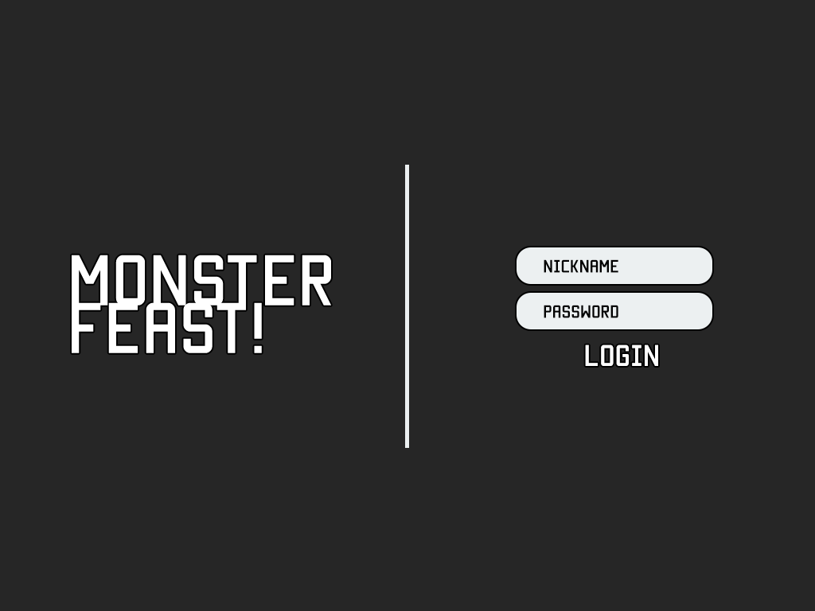

## Choose Nation



## Lobby

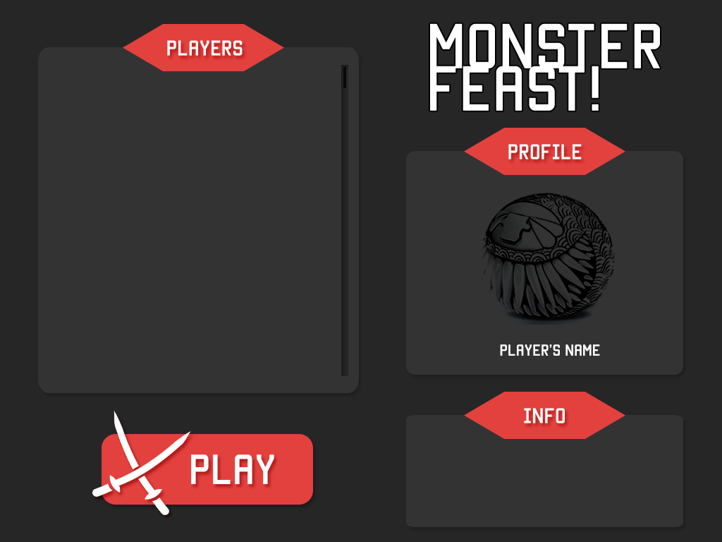

## Game

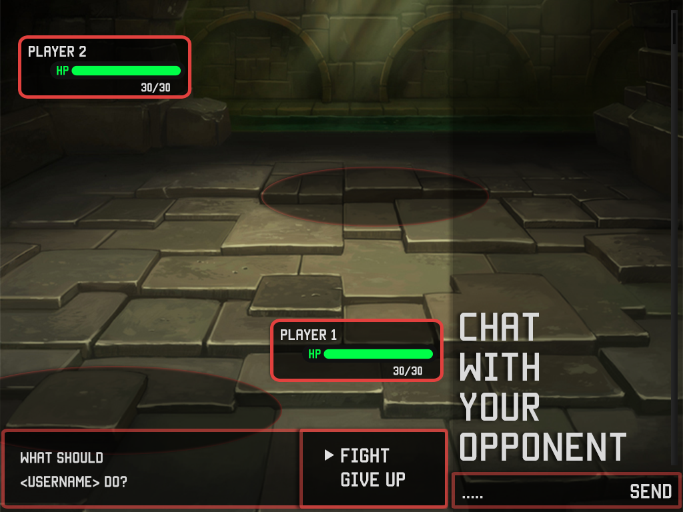

# Non-Functional Requirements

* Will be created in WCF.
* Operating system: Windows 7 / 8.1
* CPU: Intel core i3 or higher
* .NET Framework: .NET 3.5 or higher
* Hard Drive: 50 MB of free hard disk space
* Display: 800x600 or higher resolution monitor

# Rules and Constrains

* A User must register before he can enter the game.
* User must have a Character to begin battles.
* Players take turns.
* Player cannot make another move until his opponent has made his
* User must be online to chat with other players.
* Character HP/Health cannot drop below 0.
* There could be no draw.
* If experience points hit a certain barrier the character will level up.
* If a player were to leave the game it will be counted as a loss.
* After every level characters will get exactly 3 attribute points to spend.
* Every 5 levels characters can acquire new skills.
* Maximum level is 15-20.